Python Coding Challenge - Day 8 (18-06-2025)

Topic: List, Tuple, Dictionary, Set | Total Questions: 10 | Time: 60 minutes

Q1. Remove all duplicates from a list without using set()
nums = [1, 2, 2, 3, 4, 4, 5]
unique = [ ]
for num in nums:
if num not in unique:
unique.append(num)
print(unique)

OUTPUT : 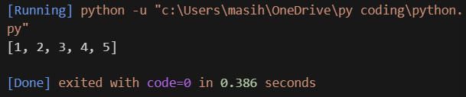

Q2. Find the second highest unique number in a list

nums = [12, 5, 9, 21, 21, 3]
unique = [ ]
for num in nums:
if num not in unique:
unique.append(num)
unique.sort(reverse=True)
print(unique[1])

OUTPUT : 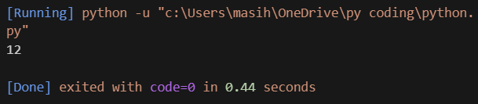

Q3. Rotate a list to the right by k positions
list = [1, 2, 3, 4, 5]
k = 2
k = k % len(list) # Handle if k > length
rotated = list[-k:] + list[:-k]
print(rotated)

OUTPUT 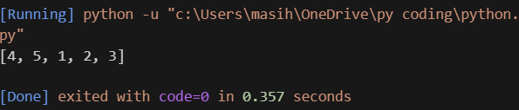

Q4. Multiply elements of each tuple in a list and return a new list
tuples = [(2, 4), (3, 5), (4, 6)]
result = [ ]
for a, b in tuples:
result.append(a * b)
print(result)

OUTPUT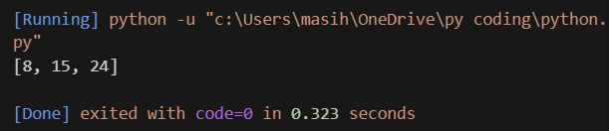

Q5. Count how many times each element occurs in a tuple
data = (1, 2, 2, 3, 1, 4, 2)
count = { }
for num in data:
if num in count:
count[num] += 1
else:
count[num] = 1
print(count)

OUTPUT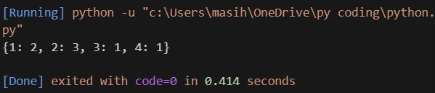

Q6. Count the frequency of each character in a string using a dictionary
text = 'banana'
freq = { }
for char in text:
if char in freq:
freq[char] += 1
else:
freq[char] = 1
print(freq)
OUTPUT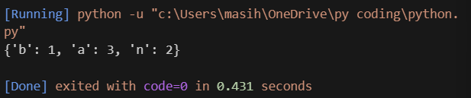

Q7. Merge two dictionaries with value sums for common keys
dict1 = {'apple': 10, 'banana': 5}
dict2 = {'banana': 3, 'orange': 7}
result = dict1.copy() # Start with the first dictionary
for key in dict2:
if key in result:
result[key] += dict2[key] # Sum values if key exists
else:
result[key] = dict2[key] # Add new key
print(result)

OUTPUT 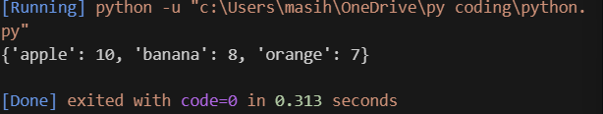

Q8. Print name(s) of student(s) with the highest marks
marks = {'Alice': 85, 'Bob': 92, 'Carol': 92}
highest = max(marks.values()) # Find the highest mark
top_students = [ ]

for name, score in marks.items():
if score == highest:
top_students.append(name)

print(top_students)

OUTPUT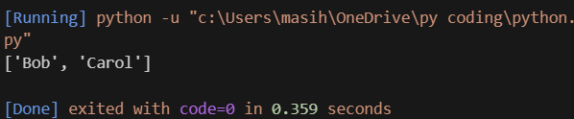

Q9. Find all common elements among 3 lists using set operations
list1 = [1, 2, 3]
list2 = [2, 3, 4]
list3 = [3, 2, 5]
common = set(list1) & set(list2) & set(list3) # Set intersection
print(common)

OUTPUT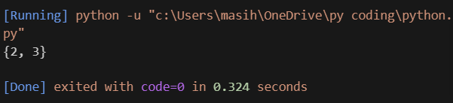

Q10. Extract and display all unique words from a sentence
sentence = 'this is a test this is fun'
words = sentence.split()
unique_words = set(words)
print(unique_words)

OUTPUT